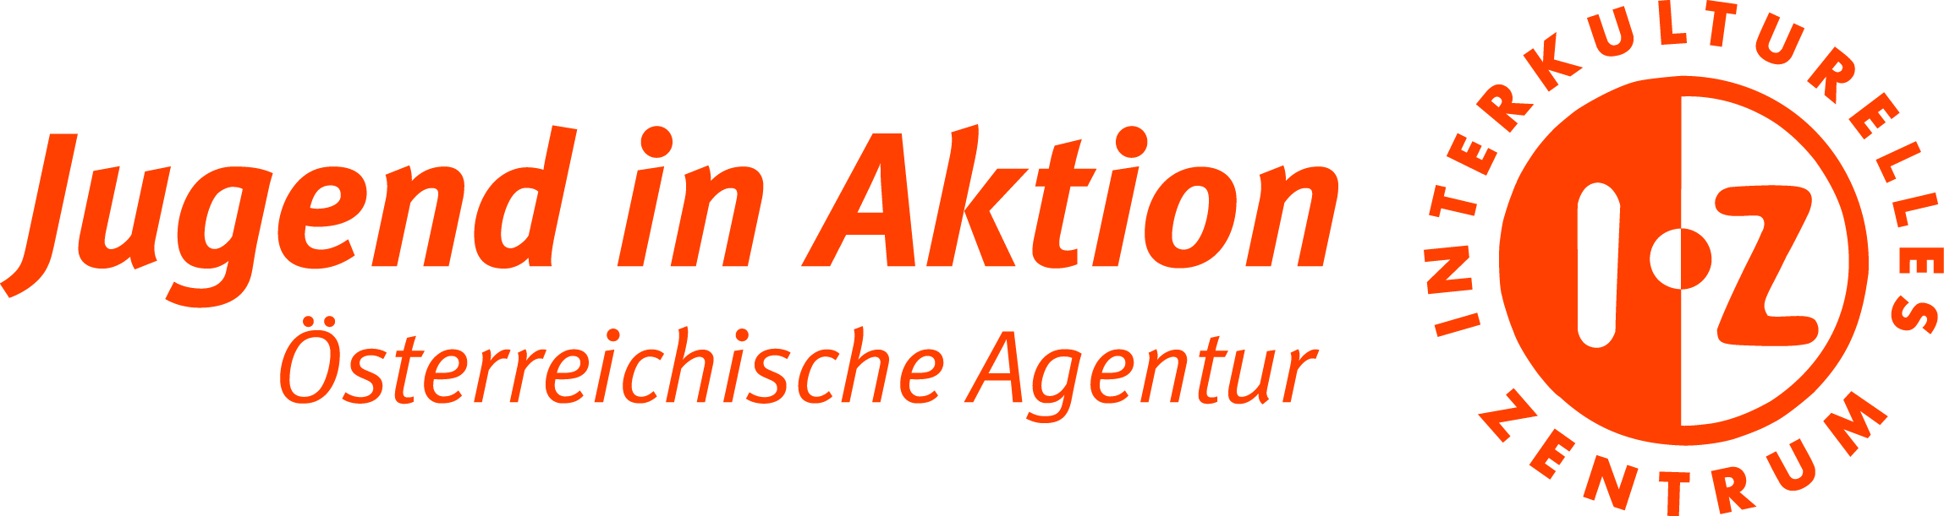

TC “ALL IN”
12. – 19.08.2018, Deutschlandsberg (Austria)
PARTICIPNAT’S APPLICATION FORM

Please, return this application form until _____________
to ________________

- Given names:
- Family name:
- Date of birth:
- Gender:
- Nationality:
--------------------------------------------------------------------------------------------------------
- Name of your organization:
- Address (street, city/town, post code, country):
- Telephone number (with international codes):
- Fax:
- E-mail address:
- My position in organization (youth worker, coordinator, volunteer, etc.):

--------------------------------------------------------------------------------------------------------
- Phone number (with international codes):
- Your e-mail address:
- Person to contact in emergency case
Name, Surname and relation to you:
Telephone number (including international code):

-------------------------------------------------------------------------------------------------------
    - YOUR NEEDS DURING THE TRAINING COURSE (if there are any):
Please tell us what your personal needs are, for example special diet because of allergy or other reasons, like being vegetarian/vegan, a guided tour through the house, to get know all important places, needs related to your religion and so on. Please also tell us, if you use technical aids like wheelchairs and if you need any assistance during the training course organized by Youth In Progress Austria.

----------------------------------------------------------------------------------------------

PLEASE GIVE US ANSWERS TO FOLLOWING QUESTIONS:
- What is your role and responsibilities within your organization?

- Why are you interested to take part in this training course? Please describe briefly your motivation and reasons for wanting to be part of this activity.

- Have you ever participated in any training course or seminar about inclusion, inclusive youth work? Where? When?

- What do you expect to learn/gain during this Training course?

- Tell us 3 interesting facts about you!

- In your opinion – what is inclusive youth work?

- With which of fallowing you are familiar and/or use in your daily life:
 | I know that it exists | I use it
Facebook
Dropbox
Google docs
WhatsApp
Twitter
Instagram
Slack

- Your language skills:
The working language is English. How good can you follow in English: | Ability to understand:
 | Understand without difficulty
 | Understand almost everything (if addressed slowly)
 | Requires a lot of translation and repetition
 | Ability to speak:
 | Speaks fluently and accurately
 | Speaks intelligibly (but not always accurate)
 | Speaks with difficulty (often looking for words)
 | Ability to read:
 | Reads fluently
 | Reads slowly
 | Reads with difficulty (needs dictionary)

Name other languages your are able to communicate:

- If there is something else you want to add……

DECLARATION:
I am aware that data gathered will be used only for All IN (identification Nr. 2016-3-AT02-KA205-001704) purposes and will be handled according to The General Data Protection Regulation (GDPR) (EU) 2016/679 and Specific privacy statement.Projects submitted under ERASMUS+ – data stored and processed in EPlusLink and eForms.
I agree that my correspondence address and information about my organization, and work can be shared with the other participants as part of the training material. If there is any reason, why it can not be shared, I will inform about it organizers at least 10 prior the training course.
I am aware, that if I participate in training activities less than 98% of the total program, my travel might not be reimbursed!

Place | Date | Signature

